2200032991
WEEK-3 TASK-3
Exercise 4: Creating and Configuring a Maven Project
- Create a New Maven Project:
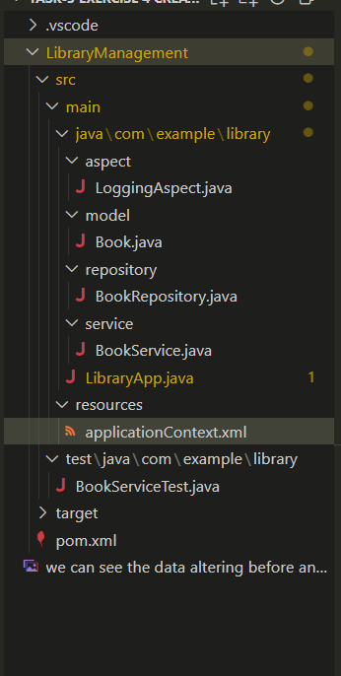
- Add Spring Dependencies in pom.xml:

<dependency>
<groupId>org.springframework</groupId>
<artifactId>spring-context</artifactId>
<version>${spring.version}</version>
</dependency>
<dependency>
<groupId>org.springframework</groupId>
<artifactId>spring-webmvc</artifactId>
<version>${spring.version}</version>
</dependency>

3.Configure Maven Plugins:
  - Configure the Maven Compiler Plugin for Java version 1.8 in the pom.xml file.
- <properties>
- <java.version>1.8</java.version>
- <spring.version>5.3.39</spring.version> <!-- last Spring 5 LTS that supports Java 8 -->
- <maven.compiler.plugin.version>3.12.0</maven.compiler.plugin.version>
- <maven.exec.plugin.version>3.2.0</maven.exec.plugin.version>
- <maven.surefire.plugin.version>3.2.5</maven.surefire.plugin.version>
- <junit.jupiter.version>5.10.2</junit.jupiter.version>
- </properties>

Example taken outputs
